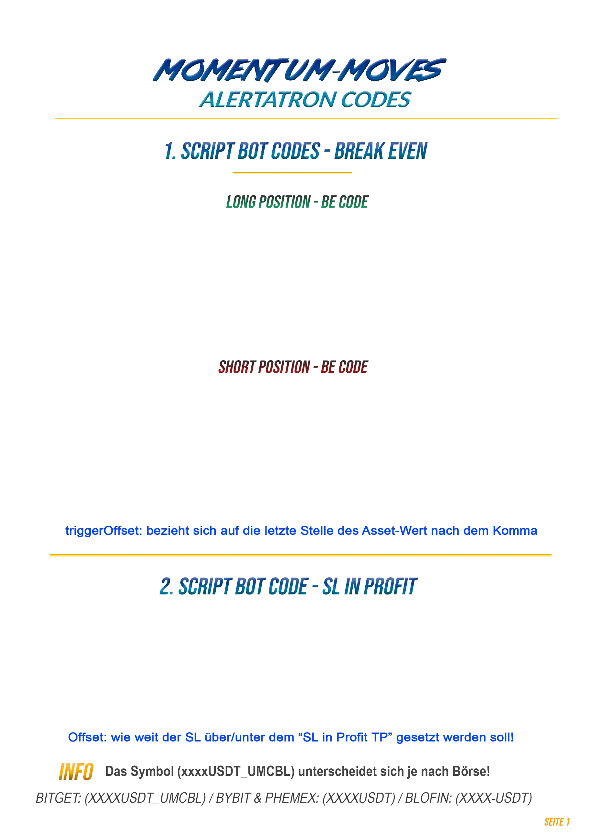
YOUR-API-NAME(xxxxUSDT_UMCBL) {
wait(3s);
stopMarket(position=0, offset=2%, trigger=last, reduceOnly=true);
}
#bot
YOUR-API-NAME(xxxxUSDT_UMCBL) {
wait(3s);
trailingTakeProfit(side=buy, amount=100%p, triggerOffset=0.00001, offset=breakeven, trailingMethod=none, trigger=last, reduceOnly=true);
}
#bot
YOUR-API-NAME(xxxxUSDT_UMCBL) {
wait(3s);
trailingTakeProfit(side=sell, amount=100%p, triggerOffset=0.00001, offset=breakeven, trailingMethod=none, trigger=last, reduceOnly=true);
}
#bot

